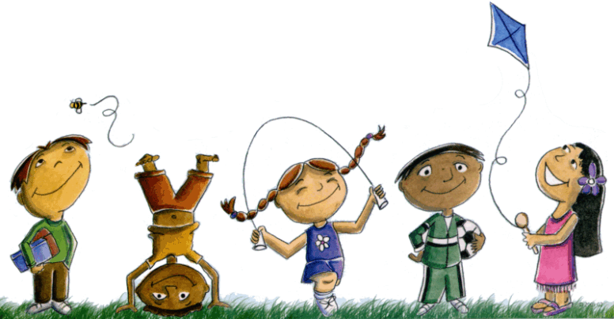

Dear Bethke Kindergarten Families,
We want to warmly welcome you to Bethke Elementary for the upcoming school year! Kindergarten is the beginning of an amazing journey. We feel honored that you will begin that journey at our elementary school and join our community of learners!
During the Kindergarten year students will take part in numerous exciting activities. They will become true readers and writers, as well as learn how math is used in our everyday lives. Our Core curriculum introduces the seven continents and students have a blast learning about landmarks, flags, animals, and other important associations. It is also in Kindergarten that students attend music, physical education, art, and media center classes. A few other activities include field trips and presentations from important people in our community.
Please feel free to contact us with any questions or concerns that may arise. We understand that the beginning of school can be a big step and we are here to help make your first experience with Bethke Elementary a memorable one!
Sincerely,
The Kindergarten Teachers
&
Staff of Bethke Elementary

